42-A-Dhruvesh B. Khandelwal

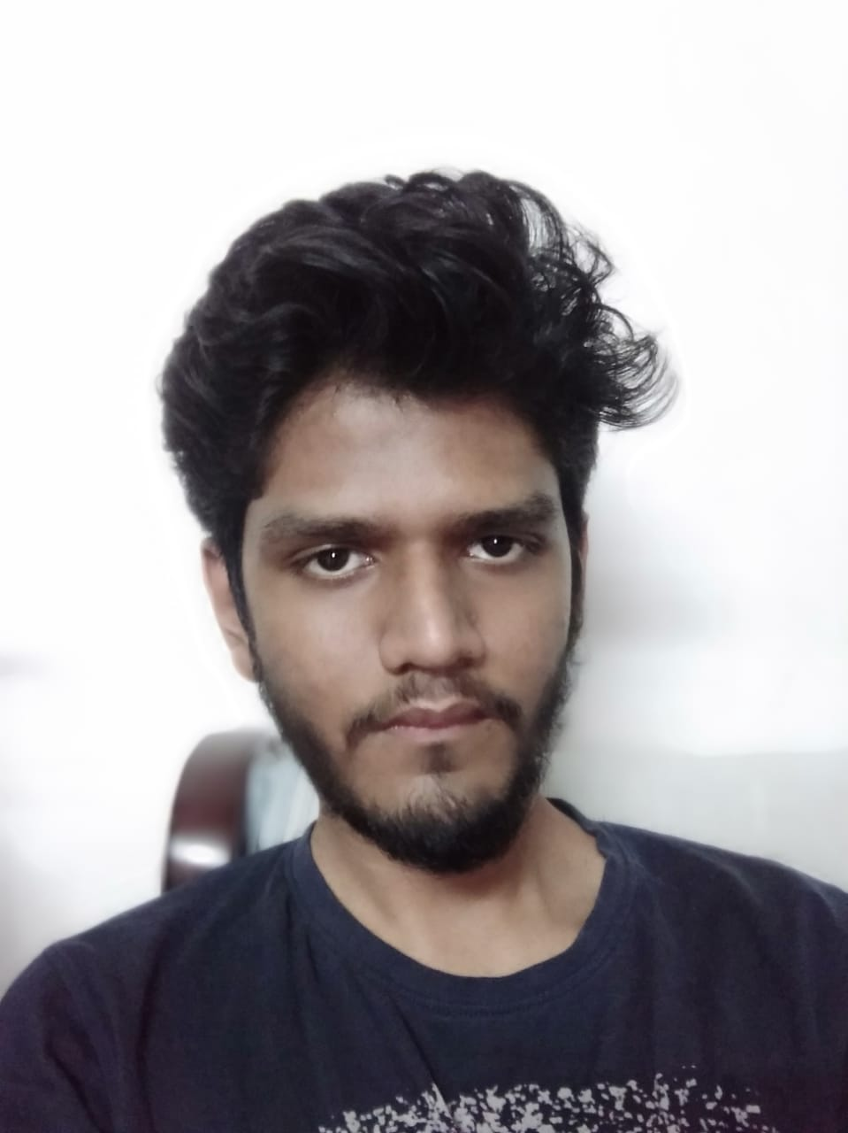

dhruvesh.khandelwal@gmail.com

7021049641

Computer

**CAREER OBJECTIVE:**

* To utilize skill and knowledge for the benefit and growth of organization.
* To learn, experience and become an expert in the field of software development.

**ACADEMIC PROFILE:**

|  |  |  |  |  |
| --- | --- | --- | --- | --- |
| DEGREE | INSTITUTION/SCHOOL | BOARD | YEAR | PERCENTAGE |
| BE in Computer | Rajiv Gandhi Institute Of Technology | University Of Mumbai | 2019 | 50.54 |
| 12th | Sulochanadevi Singhania School | ISC | 2015 | 84.6 |
| 10th | Sulochanadevi Singhania School | ICSE | 2013 | 89 |

**PROJECTS:**

INTERNSHIP PROJECTS:

Web Development at Citryx – Website for Deals,Cashback and communicating with customer for requirements.

Feedback Application for Retail Stores

Attendance Management System app

BE PROJECT: Combining Bagging And Boosting Algorithm

**ACTIVITIES:**

* **Co-Curricular Activities**
* **Game Development**
* **Workshop Volunteer**

**SKILL SETS:**

**Programming Languages: Java, Python, C/C++, Assembly, HTML, CSS, PHP, JavaScript, C#, Shell**

**Database: SQL, Oracle**

**Operating Systems: Linux, Windows**

**HOBBIES:**

Singing, Reading, Gaming